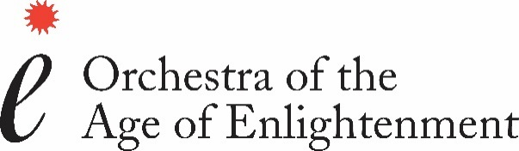

OAE APPLICATION FORM

Please send your application form with a covering letter to edward.shaw@oae.co.uk. Please also complete our online Equality & Diversity monitoring form.

The information you provide is for internal recruitment purposes and will not be shared outside the OAE without your consent.

Details of application deadlines can be found at: www.oae.co.uk

Position applied for

Personal Details
Title:
Surname:
First name(s):
Preferred name:
Home address:
Phone:
Email:
National Insurance Number:

Are you eligible to work in the UK? Yes ☐ No ☐

If you have a disability, please tell us about any adjustments we may need to make to assist you at interview:

Current or most recent employer
Name of employer:
Address:
Job title:
Start date: | Finish date (if applicable):
Description of duties:

Previous Employment (1)
Please start with the most recent and use an additional sheet if necessary
Name of employer:
Job title:
Start date: | Finish date:
Description of duties:

Previous Employment (2)
Name of employer:
Job title:
Start date: | Finish date:
Description of duties:
Please add more fields for additional positions if required

Training & qualifications
Please start with the most recent, giving details of your education and training, including any training provided by your employer(s).
Education body | Course Name | Grade/achievement

Skills and achievements
Please give details of any other skills or achievements which may help to support your application

Referees
Please give details of two referees, the first of whom should be your current employer
Name | Job title | Contact details (email & phone)

May we contact your referees prior to interview? Yes ☐ No ☐
Please note that we are unable to make an offer of employment without references.

Additional information
Please give any further information which may be relevant to your application

How did you hear about this vacancy?

- I am aware that I may be required to complete a self-disclosure form before the OAE is able to offer me a position: ☐
- I am aware that the OAE will carry out an enhanced DBS check should I be offered a position: ☐
- I confirm that the above information is correct to the best of my knowledge: ☐

Signature:
Date:

