Instructions for Film Rentals on OAE Player

Over the past two years the OAE has expanded its digital production and launched a video platform providing high quality films for you to enjoy at home and on the move. The platform OAE Player has gone through many iterations and we are constantly working to improve your experience while using it. We thank you for the support and the feedback we have received so far, and we hope to keep improving your experience of using OAE Player.
The latest improvement has been the centralization of digital content under a single banner. Up until now, OAE Player was split between two websites:
- To have unlimited access to all OAE Player content you had the option of purchasing an annual pass for £99, which would unlock all videos on the oaeplayer.com website.
- To rent individual films, you had to rent them on the oae.co.uk website
Starting on 1st December 2021, both the annual pass and renting capabilities will be merged under the banner of oaeplayer.com. This means that there is a new process to rent a single film for those who do not have an OAE Player annual pass.
If you have rented any videos through the old system and would like to keep them, don’t worry, we will transfer these across for you. Please do just let us know by emailing boxoffice@oae.co.uk

How to rent a film using the OAE Player system:
- To rent a film, go to oaeplayer.com. Once on the website, click on the new tab at the top of the page titled “Individual Film Rentals”

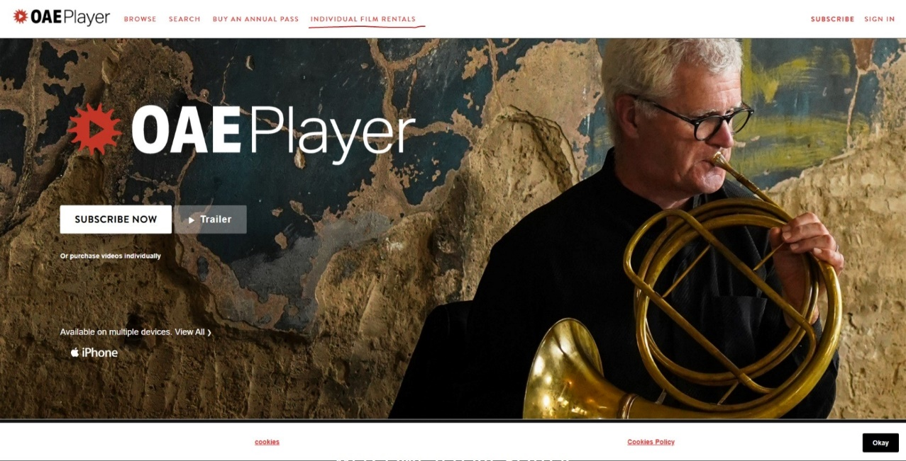
- Here, you can browse all the films available for rent. Notice the padlock sign at the bottom right corner of each video. This means that the film is locked. To watch it, either buy the OAE Player Annual Pass or click on the video to rent it.

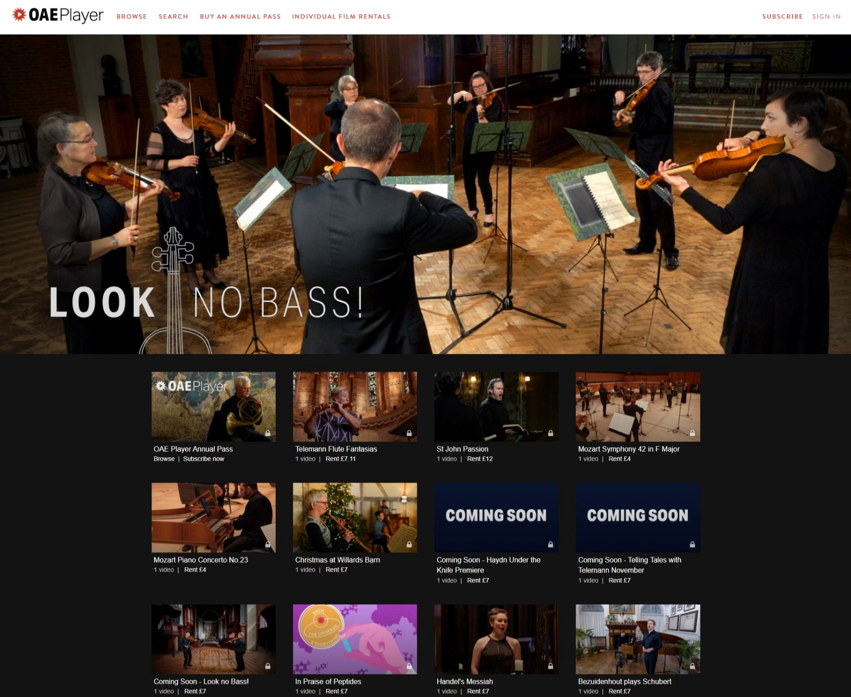

- Once you have clicked on the video of your choice, you will be taken to its rental page. Click on the white button saying “Rent”. 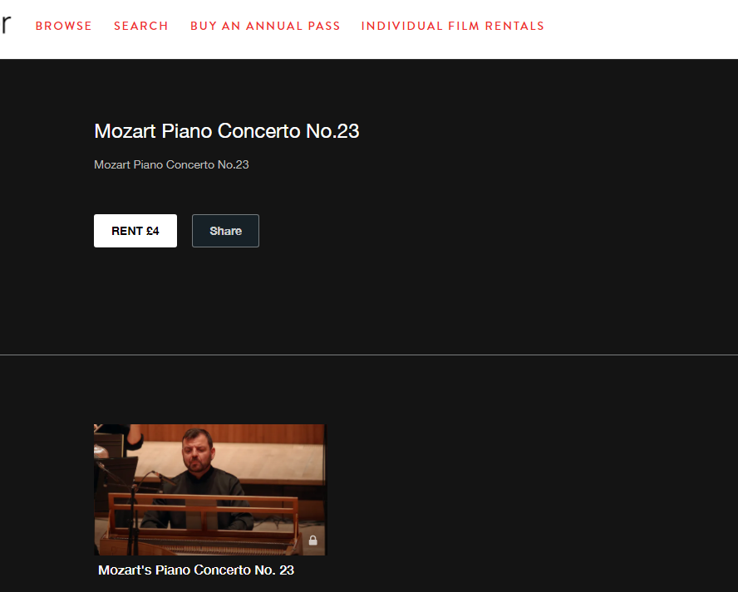

- You will now be taken to oae.co.uk website. If you are not logged in to our website, you will see a window asking you to log onto your OAE account or to create a new one. Each rental of the film is called a “Ticket”. Sometimes you might even see the date of the performance, which may be far in the future. Don’t let be confused by this quirk. Due to the new technology we are operating with, some aspects of this process aren’t entirely intuitive. We will continue to work tirelessly to improve the user experience.

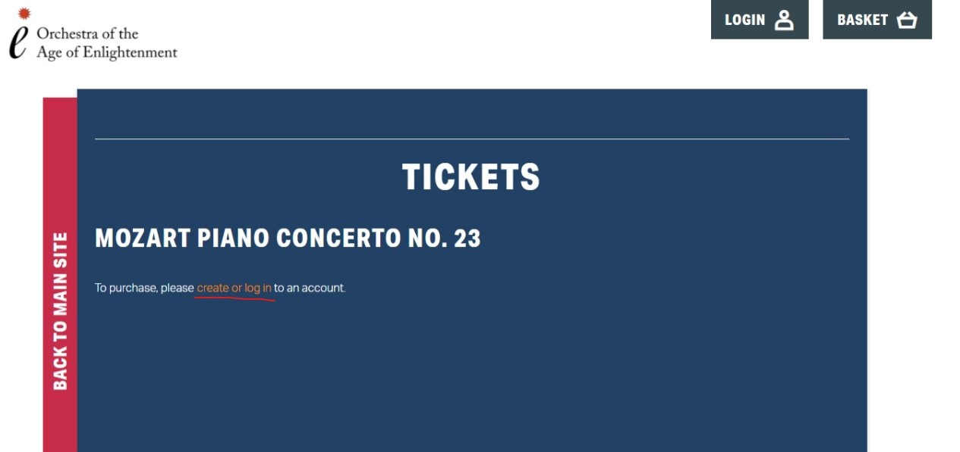

- Once you have logged in, you will be taken to the ticket selection page. Please change the ticket number from 0 to 1 and press “Add to Basket”
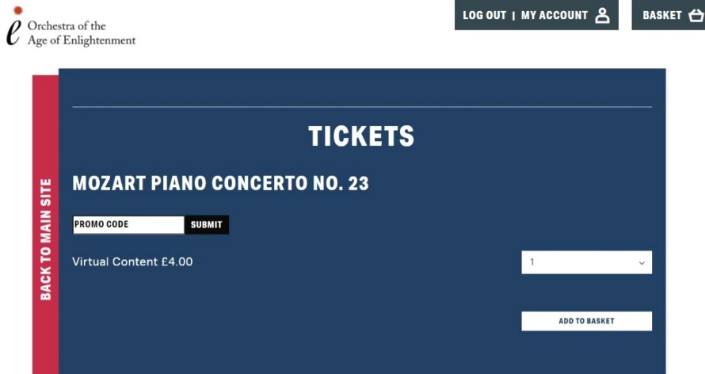

- Now you are taken to your “Basket” page. Here, you can either redeem a gift certificate or buy the film by clicking the “Checkout” button. On the next page, scroll down and press the “Buy Now” button.

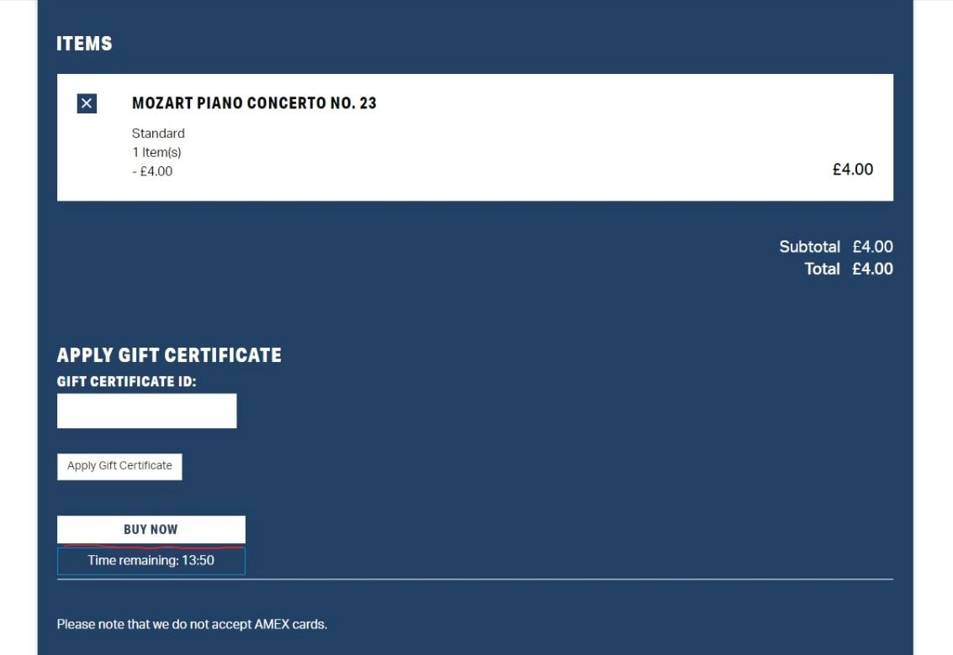

- Now input your card details and purchase the film. Once the payment has gone through, you will see a confirmation page. You can now close oae.co.uk website.
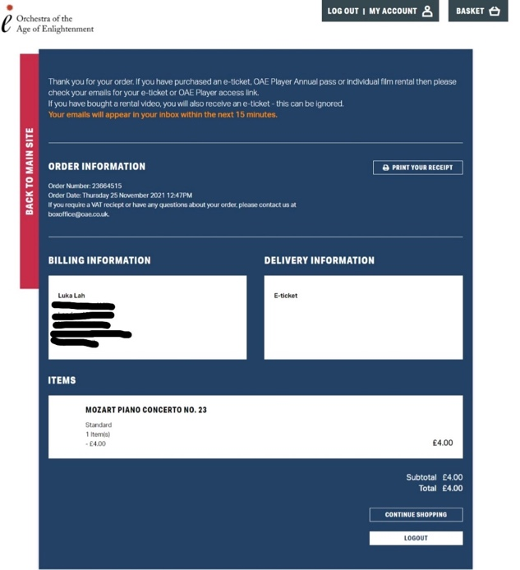
- In the 10-15 minutes after purchase, you will receive three emails:
  - An order confirmation email
  - An E-ticket
  - A link to the video
The order receipt and e-ticket are for your discretion. The email with the link is the fastest way to reach the film you wish to watch. Please, save the email containing the link for future reference. The film should also be available through the OAE Player platform if you log into your OAE Player account. To log on, simply click on the Sign In button in the top right corner of the OAE Player front page, and input your email. This will prompt the system to send you an email which will allow you to log in.

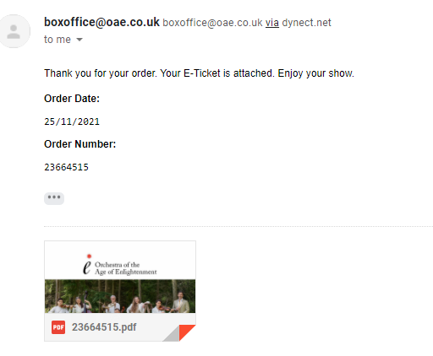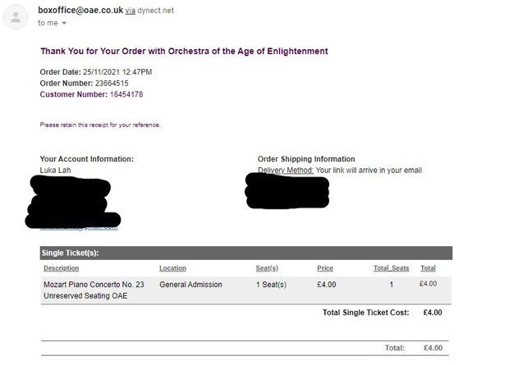
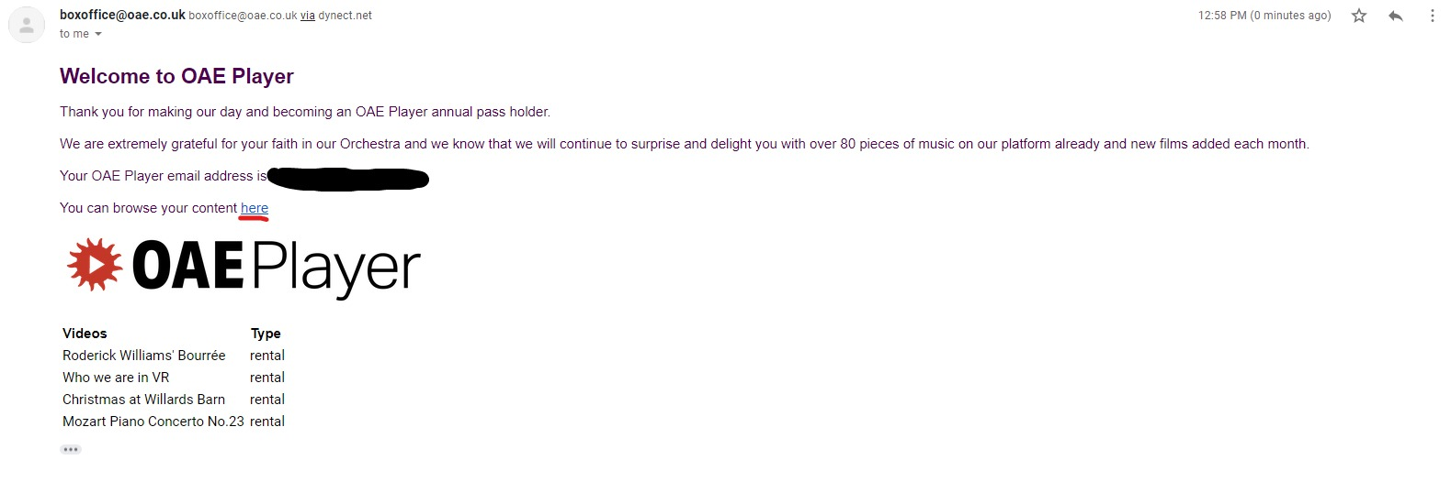
- There are some issues that we are aware of and are working as fast as we can to solve them.
  - Sometimes when you have purchased more than one film, the link you receive will not work. Instead of showing you the latest film you bought, it will show you a film you have bought before. If this happens to you, please let us know and we will try to resolve the issue for you as fast as we can.
  - It may take up to 15 minutes or more to receive your three emails. Please let us know if you have not received it within 12 hours.
  - Once you have bought the film, it may be hard to find it on the OAE Player platform without the original email with the link. The easiest way to find your films is to once again click on “Individual Film Rentals” and find the film without the padlock sign in the bottom right corner.

