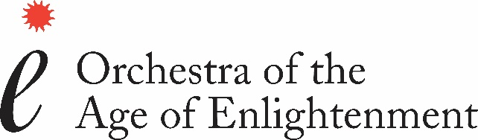

OAE Section Viola

Role overview

The Orchestra of The Age of Enlightenment is inviting applications for a freelance Section Viola vacancy, positioned number 3 on the fixing list. The OAE operates rotating string section seating; the successful candidate should feel comfortable to sit up to Section Principal if required.

The position will cover the full range of repertoire performed by the OAE, which broadly includes Monteverdi to Mahler. Experience in historically informed performance is essential.

The successful candidate will be invited to become a Player Member of the OAE (see below).

Auditions & trials

Successful applicants will be invited to audition and/or trial. Auditions will take place in London during the week commencing 25 July 2022. Further information on the selection process will be sent by email following a review of all applications.

Some applicants may be asked to submit a video to supplement their application to assist in shortlisting. These applicants will be notified shortly after application deadline that they are required to submit a video by 13 June 2022.

Details of the audition repertoire can be found at: https://oae.co.uk/jobs/section-viola/

How to apply

Candidates should e-mail the completed application form to recruitment@oae.co.uk. They should also provide two references (full details on the application form). All candidates should also fill out our online Equality & Diversity Monitoring form.

Please include any access requirements in the relevant section of the application form. If you have any questions about access, please email recruitment@oae.co.uk.

All applicants should be eligible to work in the UK.

Tenure

Freelance.

We look for a high level of commitment from our Player Members and, as a general guideline, would expect players to take on around two thirds of work offered to each individual.

Deadline

13 May 2022

Diversity & inclusion

The OAE is committed to diversity & inclusion and creating a welcoming environment for all musicians. We want to be representative of the communities we work in and welcome applications from all sections of society. We particularly encourage applications from black, Asian and minority ethnic candidates and candidates with disabilities as these groups are currently under-represented in our workforce.

About the OAE

The OAE is a freelance, period instrument orchestra specialising in, but not exclusively limited to, repertoire from the Age of Enlightenment: from the Baroque, Classical and Romantic tradition. As a self-governing orchestra, all members are expected to take an active part in the governance and promotion of the orchestra. This could include being a member of our Players’ Artistic Committee which is responsible for artistic direction and the maintaining of standards. Other responsibilities could include being a member of audition panels, supporting fundraising, contributing to our YouTube channel and supporting our education work across the UK.

The 2021/22 Season sees the OAE working alongside our Principal Artists, continuing our residency at London’s Southbank Centre and Glyndebourne Festival Opera as well as touring nationally and internationally. Off the concert platform, the OAE has a vibrant Education Programme.

In October 2020, we launched our digital subscription platform, OAE Player, which features over fifty new music performance videos, created specifically for an online audience and filmed in-house by the OAE’s digital team.

Acland Burghley School

In summer 2020 the OAE moved into Acland Burghley School in Camden, North London. The residency – a first for a British orchestra –allows us to live, work and play amongst the students of the school. Three offices have been adapted for our administration team, alongside a recording studio/library. The Grade II listed school assembly hall is used as a rehearsal space, so for the first time, we are all in the in the same place: players, staff and library.

The school is not just the OAE’s landlord or physical home. Instead, it offers the opportunity to build on twenty years of work in the borough through OAE’s long-standing partnership with Camden Music. Having already worked in eighteen of the local primary schools that feed into ABS, the plans moving forward are to support music and arts across the school into the wider community.

This new move underpins the OAE’s core ‘enlightenment’ mission of reaching as wide an audience as possible. The move has been made possible with a leadership grant of £120,000 from The Linbury Trust, one of the Sainsbury Family Charitable Trusts. Their support has facilitated the move to the school and is underwriting the first three years of education work.

