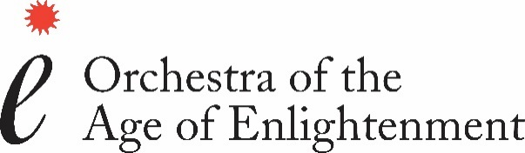

Candidate number

(Office use only)

**APPLICATION FORM – OAE Rising Stars Scheme**

Please send your completed application to [risingstars@oae.co.uk](mailto:risingstars@oae.co.uk).

If you would rather post your application, please send it to: Edward Shaw, Orchestra of the Age of Enlightenment, Acland Burghley School, 93 Burghley Road, London NW5 1UH.

The information you provide is for internal recruitment purposes and will not be shared outside the OAE without your consent.

Details of application deadlines and audition dates can be found at <https://oae.co.uk/jobs/rising-stars-of-the-enlightenment>.

|  |
| --- |
| **Personal Details** |
| **Title:** |
| **Surname:** |
| **First name(s):** |
| **Preferred name:** |
| **Voice:** |
| **Home address:** |
| **Phone:** |
| **Email:** |

|  |
| --- |
| **Eligibility to work in the UK** |
| **Are you eligible to work in the UK? Yes**   **No** |
| **If necessary, please give details:** |

|  |
| --- |
| **Disability** |
| **If you have a disability, please tell us about any adjustments we may need to make to assist you during the audition process:** |

|  |  |  |
| --- | --- | --- |
| Musical Training & qualifications | | |
| Please start with the most recent, giving details of your education and training, with start and finishing dates where applicable. | | |
| **Education body** | **Course Name** | **Grade/achievement** |
|  |  |  |
|  |  |  |
|  |  |  |
|  |  |  |
|  |  |  |
|  |  |  |
|  |  |  |

|  |
| --- |
| Name of Current Singing Teacher or Coach |
|  |

|  |
| --- |
| Name of former singing teachers (if applicable) |
|  |
|  |
|  |

|  |
| --- |
| **Referees** |
| **Please supply one reference. This should be emailed directly from the referee to** [**risingstars@oae.co.uk**](mailto:risingstars@oae.co.uk)**.** |

|  |  |
| --- | --- |
| **How did you hear about this vacancy?** |  |

|  |
| --- |
| **relevant musical experience** |
| **On one page only, please detail any musical experience relevant to this application.** |
|  |

**I confirm that the above information is correct to the best of my knowledge:**

|  |  |
| --- | --- |
| **Signature:** |  |
| **Date:** |  |